### NALAYATHIRAN

### TEAMID:PNT2022TMID47272

### TOPIC: IoT Based Safety Gadget for Child Safety Monitoring and Notification

**OBJECTIVE:**

* CHILDRENS SAFETY AND TRACKING IS MORE IMPORTANT NOWDYAS.
* THIS SYSTEM IS DEVELOPED USING ARDUINO AND ESP 32 AND RASPBERRY PI.

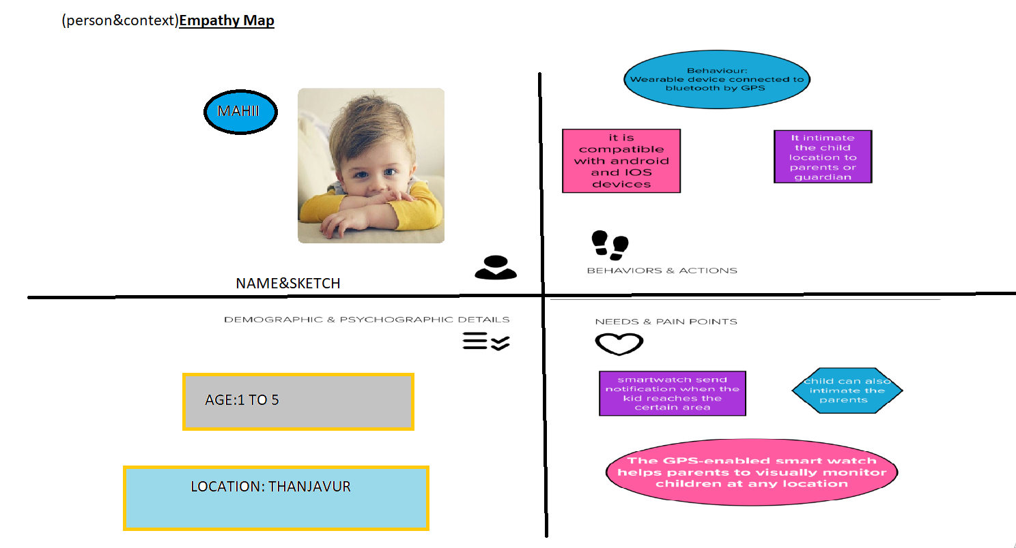

**TEAM LEAD:**

MAHESH.K.S

**TEAM MEMBERS:**

SRIDHAR.G

KALAIMUKILAN.S

ENIYAVAN.M